**Project Name: Barber’s Choice**

**Project Member:**

**Prajwal Parashkar 220943120078**

**Prajwal Jagtap 220943120040**

**Dhanraj Karve 220943120024**

**Ayyajkhan Pathan 220943120014**

**Introduction of Project:**

For many people, heading to a Luxury salon every few weeks is seen as an expense they simply can’t afford. In this scenario many people choose local inexpensive salons that they can afford. To keep the prices low, salon owners are dependent on local products.

We are developing common web-based platform for Salon. This is efficient app which helps Salon owners in finding products that they required. Barber Choice provides faster response to get Salon Product as well as insuring the availability of Products in your chosen location.

Local Products are relatively cheap but they are unorganized. Unorganized products are nothing but those products which does not have significant market share and they are not available radially. That’s where our website comes in picture.

This unorganized market will be organized through our website. With the increasing number of internet users, now millions can view our website at anytime from anywhere. Barbers choice will also help whole sellers to increase their business. An online store has more visibility ,and a vast number of people from any place can easily access the eCommerce website.

we believe that grooming is an important part of self-care, and we are dedicated to providing the best products for our customers. Whether you are a professional barber or stylist, or simply looking for products to use at home, we have everything you need to create your perfect style.

Our online store features a vast selection of products, including clippers, trimmers, razors, scissors, combs, brushes, hair products, and more. We work with the leading brands in the industry to bring you top-quality products that you can rely on. Our range of products is constantly expanding, so you can be sure to find the latest and greatest products available.

We are committed to providing exceptional customer service, and our team is always here to help you with any questions or concerns you may have. We understand that finding the right products can be overwhelming, so we have created a user-friendly website that makes it easy to browse and find what you need.

We believe that grooming should be accessible to everyone, which is why we offer competitive pricing. Our goal is to make it easy for you to get the products you need, when you need them, so you can focus on looking and feeling your best.

We understand that finding the right products can be overwhelming, which is why we have created a user-friendly website that makes it easy to browse and find what you need. Our website features detailed product descriptions, reviews from other customers, and helpful tips and advice to help you choose the right products for your needs. We also offer a variety of payment options and fast, reliable shipping, so you can get the products you need, when you need them.

**Objective and Scope of Project:**

The main purpose of BARBER-CHOICE application is to make salon owners life easier by providing them services to find local product with comfort. Our website will provide rarely and frequently required products. Providing all un-organized salon products at one place.

Barber-choice is like middleware between whole seller and customer. For now, our website provides only salon products which narrow down the website and increases efficiency of workflow.

* Product offerings: A barbershop and salon product website typically offers a vast range of grooming products, including clippers, trimmers, razors, scissors, combs, brushes, hair products, and more. These products may be targeted at professionals in the industry or individual consumers who are looking to groom themselves at home.
* Brand partnerships: The website may partner with various grooming brands to offer their products to customers. This may include well-known brands that specialize in grooming, as well as smaller, niche brands that cater to specific grooming needs
* Customer engagement: A barbershop and salon product website may engage with customers through various means, including product reviews, blog articles, social media, and email newsletters. These engagement methods help the website to build a community of loyal customers who can share their experiences and provide feedback
* Professional resources: For professional barbers and stylists, a barbershop and salon product website may offer resources such as training videos, industry news, and networking opportunities. These resources can help professionals to enhance their skills and stay up-to-date with the latest trends and techniques.

By providing high-quality products, engaging with customers, and offering resources for professionals, Barber’s choice can build a strong and loyal customer base.

**Modification and improvement over the existing Implementation:**

**Existing Model for eCommerce of saloon products. -**

1. Limited availability: Local salon products may only be available in select stores or salons, which can make them difficult to find. This may be due to limited production or distribution of the products, which can create scarcity.
2. Regional limitations: Some salon products may only be available in certain regions, which can make them difficult to obtain outside of those areas. This may be due to differences in regulations or consumer preferences, which can affect product availability.
3. Exclusivity agreements: Some salon products may be exclusive to certain salons or distributors, which can limit their availability to other locations. This may be due to contractual agreements between the product manufacturer and the distributor or salon.
4. High demand: If local salon products are in high demand, they may be difficult to get due to limited stock or long wait times. This can be especially true if the products are seasonal or are only available for a limited time.

After implementation of project

1. Centralized Location: Barber’s choice website can provide a centralized location where customers can easily find and purchase local salon products. This can help to simplify the purchasing process and eliminate the need to search for products in multiple stores or salons.
2. Access to Products: Barber’s choice website can provide access to local salon products that may not be available in all regions. This can help customers who live in areas where certain products are not available to purchase the products they want without having to travel to other regions.

**Project Plan:**

No. of User’s and Modules

**Users-** The person or organization that will use the project's product or service.

No. of user’s and specify each user work in brief.

For Ex: Admin, Customer etc.

1. Customer -
2. Customer can see all the products with their price, description, price and other details and can freely roam the website without login.
3. If customer is not registered then he has to register first.
4. After clicking on Add to Cart button on the product card that specific product will be added to the user’s cart. If Customer is not logged in he will be directed to the login page.
5. User can continue shopping after adding to cart.
6. Clicking on the cart icon will redirect to the cart page. Here Customer can see all the products that have added to cart. Customer can remove product from the cart
7. Customer click on proceed to buy will redirect to address page. After confirming payment will be redirected to payment gateway.
8. Customer can review the product.
9. Admin –
10. Admins adds new products.
11. Admins can remove products and edit the product details including pricing, description.

**Modules** - Module is a logical separation of a functionality within a project.

Specify the number of modules and their working in brief.

For Ex:

Modules for Online shopping portal:

1.Customer management

2.Billing and payment

3.Product management

**Implementation Technologies:**

1. **Spring Framework:**

Spring Framework is a Java platform that provides comprehensive infrastructure support for developing Java applications. Spring handles the infrastructure so you can focus on your application.

Spring enables you to build applications from “plain old Java objects” (POJOs) and to apply enterprise services non-invasively to POJOs. This capability applies to the Java SE programming model and to full and partial Java EE.

**1.1 Features of Spring Framework:**

**1. Lightweight**

Spring is modular lightweight framework which allows you to selectively use any of its modules on the top of Spring Core.

**2. Inversion of Control (IOC)**

This is another top feature of Spring framework where application dependencies are satisfied by the framework itself. Framework creates the object in runtime and satisfies application dependencies.

**3. Aspect Oriented Programming (AOP)**

Aspect Oriented Programming (AOP) is very popular in programming world and in Spring it is well implemented. Developer can use Aspect Oriented Programming (AOP feature of Spring to develop application in which business logic is separated from system services.

**4. Container**

Spring provides their own container for managing the bean lifecycle.

**5. MVC Framework**

Spring MVC Framework is used for developing MVC based web applications.

**6. Transaction Management**

Spring framework provides generic Transaction Management layer which can be used with or without J2EE(JEE) environment.

**7. JDBC Exception Handling**

Spring provides their own abstraction of JDBC exception which further simplifies the exception handling in program.

**1.2 Advantages of Spring Framework:**

**1. Solving difficulties of Enterprise application development**

Spring is solving the difficulties of development of complex applications, it provides Spring Core, Spring IOC and Spring AOP for integrating various components of business applications.

**2. Support Enterprise application development through POJOs**

Spring supports development of Enterprise application development using the POJO classes which removes the need of importing heavy Enterprise container during development. This makes application testing much easier.

**3. Easy integration other frameworks**

Spring designed to be used with all other frameworks of Java, you can use ORM, Struts, Hibernate and other frameworks of Java together. Spring framework do not impose any restriction on the frameworks to be used together.

**4. Application Testing**

Spring Container can be used to develop and run test cases outside enterprise container which makes testing much easier.

**5. Modularity**

Spring framework is modular framework and it comes with many modules such as Spring MVC, Spring ORM, Spring JDBC, Spring Transactions etc. which can used as per application requirement in modular fashion.

**6. Spring Transaction Management**

Spring Transaction Management interface is very flexible it can configure to use local transactions in small application which can be scaled to JTA for global transactions.

1. **Spring Boot**

Spring Boot is an open-source Java-based framework designed to simplify the process of developing and deploying standalone, production-ready applications. Spring Boot is built on top of the popular Spring framework, and it offers a range of features and functionality that help developers to quickly and easily build robust and scalable applications.

Some of the key features of Spring Boot include:

1. Autoconfiguration: Spring Boot's autoconfiguration feature automatically configures the application based on the dependencies included in the project, reducing the need for manual configuration.
2. Embedded server: Spring Boot includes an embedded server, which means that developers do not need to configure and deploy a separate server to run the application.
3. Simplified dependency management: Spring Boot includes a range of pre-configured dependencies, which can be easily managed and updated using Maven or Gradle.
4. Production-ready features: Spring Boot includes a range of production-ready features, such as health checks, metrics, and security, which can be easily configured and integrated into the application.
5. Rapid development: Spring Boot's simplicity and ease-of-use enable developers to rapidly prototype and develop applications, reducing the time-to-market for new projects.

Overall, Spring Boot is a powerful and flexible framework that enables developers to quickly and easily build production-ready applications using the Spring framework.

**2.1** **MySQL**

MySQL, the most popular Open Source SQL database management system, is developed, distributed, and supported by Oracle Corporation.

**Features of MySQL:**

* **MySQL is a database management system.**

A database is a structured collection of data. It may be anything from a simple shopping list to a picture gallery or the vast amounts of information in a corporate network. To add, access, and process data stored in a computer database, you need a database management system such as MySQL Server. Since computers are very good at handling large amounts of data, database management systems play a central role in computing, as standalone utilities, or as parts of other applications.

* **MySQL databases are relational.**

A relational database stores data in separate tables rather than putting all the data in one big storeroom. The database structures are organized into physical files optimized for speed. The logical model, with objects such as databases, tables, views, rows, and columns, offers a flexible programming environment.

* **MySQL software is Open Source.**

Open Source means that it is possible for anyone to use and modify the software. Anybody can download the MySQL software from the Internet and use it without paying anything.

* **The MySQL Database Server is very fast, reliable, scalable, and easy to use.**

MySQL Server was originally developed to handle large databases much faster than existing solutions and has been successfully used in highly demanding production environments for several years. Although under constant development, MySQL Server today offers a rich and useful set of functions. Its connectivity, speed, and security make MySQL Server highly suited for accessing databases on the Internet.

* **MySQL Server works in client/server or embedded systems.**

The MySQL Database Software is a client/server system that consists of a multithreaded SQL server that supports different back ends, several different client programs and libraries, administrative tools, and a wide range of application programming interfaces (APIs).

1. **React**

React is an open-source JavaScript library that is used for building user interfaces (UIs) for web applications. Developed and maintained by Facebook, React was initially released in 2013 and has since become one of the most popular front-end development tools.

React allows developers to build UI components that can be reused across an application, making it easier to maintain and update the codebase. React's core feature is the Virtual DOM (Document Object Model), which is a lightweight in-memory representation of the real DOM. React uses the Virtual DOM to render UI components, which makes it faster and more efficient than other front-end frameworks that rely on direct manipulation of the real DOM.

Some of the key features of React include:

1. Component-based architecture: React's component-based architecture allows developers to break down the UI into reusable and modular components, making it easier to manage and update the codebase.
2. JSX: React uses JSX (JavaScript XML) to enable developers to write HTML-like syntax within their JavaScript code, which makes it easier to create and manage UI components.
3. Virtual DOM: React's Virtual DOM allows for efficient rendering of UI components, improving the performance of web applications.
4. Unidirectional data flow: React uses a unidirectional data flow, which means that data flows in one direction, from parent to child components. This makes it easier to manage and update the data within an application.
5. Large community and ecosystem: React has a large and active community, which provides support, resources, and a wide range of third-party libraries and tools.

Overall, React is a powerful and flexible tool for building complex and dynamic user interfaces for web applications. Its component-based architecture, efficient rendering, and large community make it a popular choice for front-end development.

1. **Hardware and Software Requirements (Minimum):**

**Hardware:**

1. Intel i5 processor 3rd generation or later / AMD Ryzen 5000 5th generation or later

2. 8GB ram.

3. Windows 11 Home edition or later.

4. 512 GB SSD Space

5. Data Connection 10 Mbps

**Software:**

1. Eclipse 14.24
2. MySQL 8.0.31 with Workbench 8.0
3. Google Chrome version 79.0
4. Apache Tomcat Server 8.5
5. Maven Dependencies
6. **ER Diagram:**

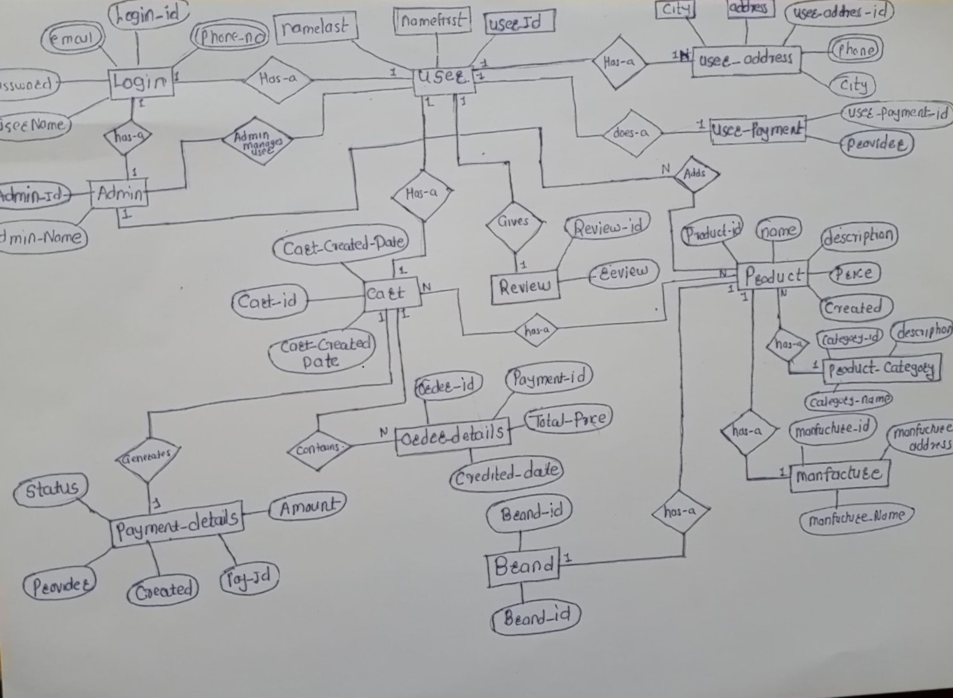

Figure 1: ER Diagram

1. **Table Structures:**
2. **Table name: Admin**

**Column name Type**

admin_id int NO PRI auto_increment

admin_last_login varchar(20) YES

admin_namefirst varchar(20) YES

admin_namelast varchar(40) YES

login_id int YES

user_user_id int

1. **Table name:Brand**

**Column name Type**

brand_Id int NO PRI auto_increment

brand_name varchar(50) YES

1. **Table name:Cart**

**Column name Type**

cart_id int NO PRI auto_increment

cart_created_date date YES

cart_modified_date date YES

cart_quantity int NO

user_id int YES

1. **Table name:Login**

**Column name Type**

login_id int NO PRI auto_incremen

email varchar(255) YES

password varchar(255) YES

phone_number bigint NO

username varchar(255) YES

**5.Table name:Manufacture**

**Column name Type**

manufacturer_id int NO PRI auto_increment

manufacturer_address varchar(255) YES

manufacturer_name varchar(255) YES

login_id int YES

**6.Table name:Order_Details**

**Column name Type**

order_details_id int NO PRI auto_increment

created_date date YES

order_details_ammount double NO

payment_id int NO

status varchar(255) YES

user_id int NO

cart_id int  YES

**7.Table name:Payment Details**

**Column name Type**

payment_details_id int NO PRI auto_increment

ammount double NO

created_date date YES

modified_date date YES

provider varchar(255) YES

status varchar(255) YES

order_id int YES

**8.Table name:Products**

**Column name Type**

product_id int NO PRI auto_increment

deleted_date date YES

created_date date YES

modified_date date YES

product_description varchar(255) YES

product_name varchar(255) YES

product_price double NO

brand_brand_id int YES

manufacturer_manufacturer_id int YES

category_id int YES

discount_id int YES

cart_cart_id int YES

**9.Table name:Product_cart**

**Column name Type**

product_product_id int NO

cart_cart_id int NO

**10.Table name: Product_category**

**Column name Type**

category_id int NO PRI auto_increment

deleted_date date YES

category_description varchar(255) YES

category_name varchar(255) YES

created_date date YES

modified_date date  YES

**11.Table name: Product_discount**

**Column name Type**

product_discount_id int NO PRI auto_increment

deleted_date date YES

created_date date YES

modified_date date YES

product_discount_is_active bit(1) NO

product_discount_name varchar(255) YES

product_discount_percentage double NO

**12.Table name: review**

**Column name Type**

review_id int NO PRI auto_increment

review varchar(255) YES

product_id int YES

user_id int YES

**13.Table name: user**

**Column name Type**

user_id int NO PRI auto_increment

namefirst varchar(255) YES

namelast varchar(255) YES

login_id int  YES

**14.Table name: user_address**

**Column name Type**

user_address_id int NO PRI auto_increment

address_line1 varchar(255) YES

address_line2 varchar(255) YES

city varchar(255) YES

country varchar(255) YES

phone_nummber bigint NO

postal_code int NO

telephone bigint

user_id int YES

**15.Table name: user_payment**

**Column name Type**

user_payment_id int NO PRI auto_increment

provider varchar(255) YES

user_id int YES

**16.Table name: user_website_feedback**

**Column name Type**

feedback_id int NO PRI auto_increment

feedback_text varchar(255) YES

user_id int YES

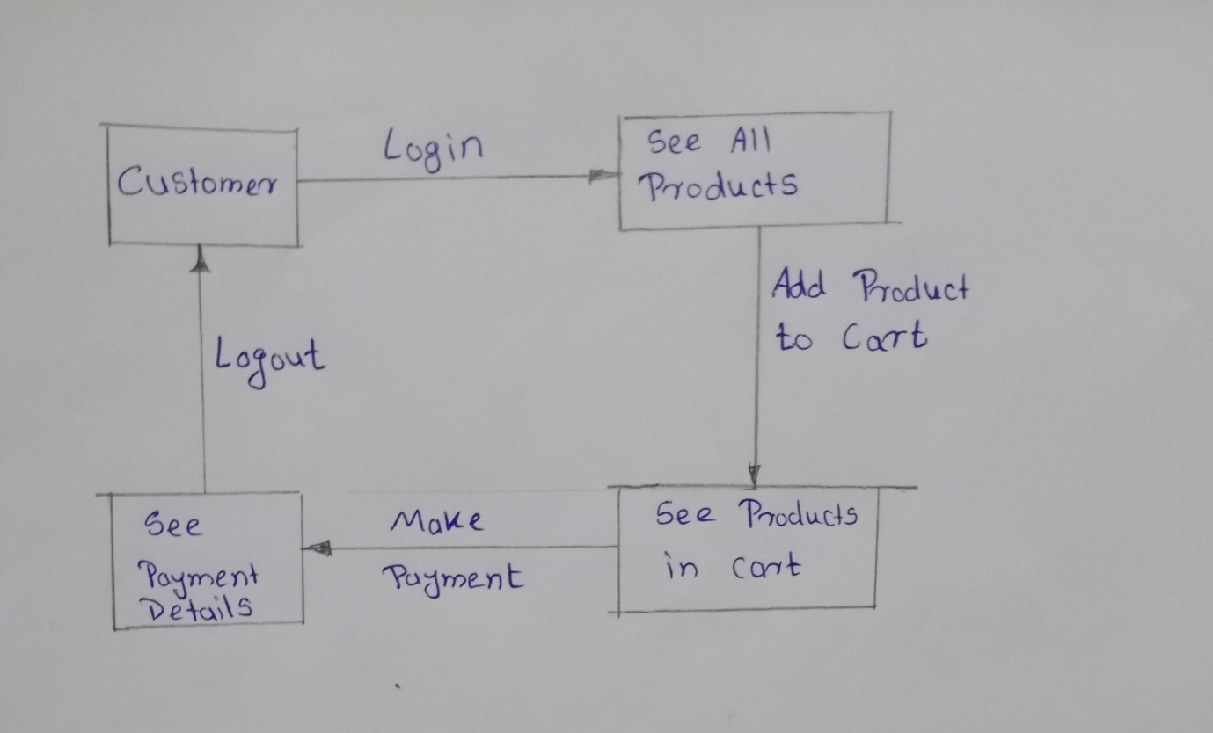

Figure 3: Collaboration Diagram

Figure : Component Diagram

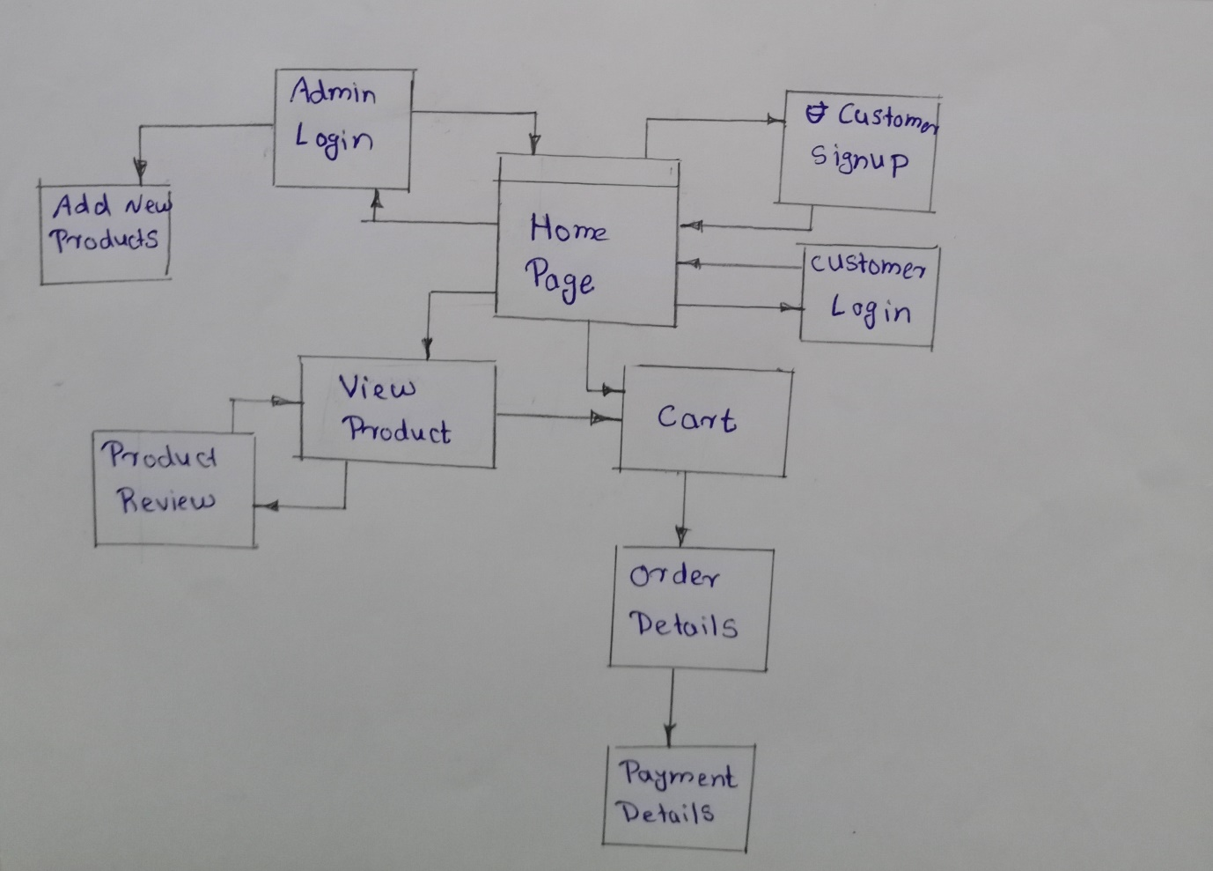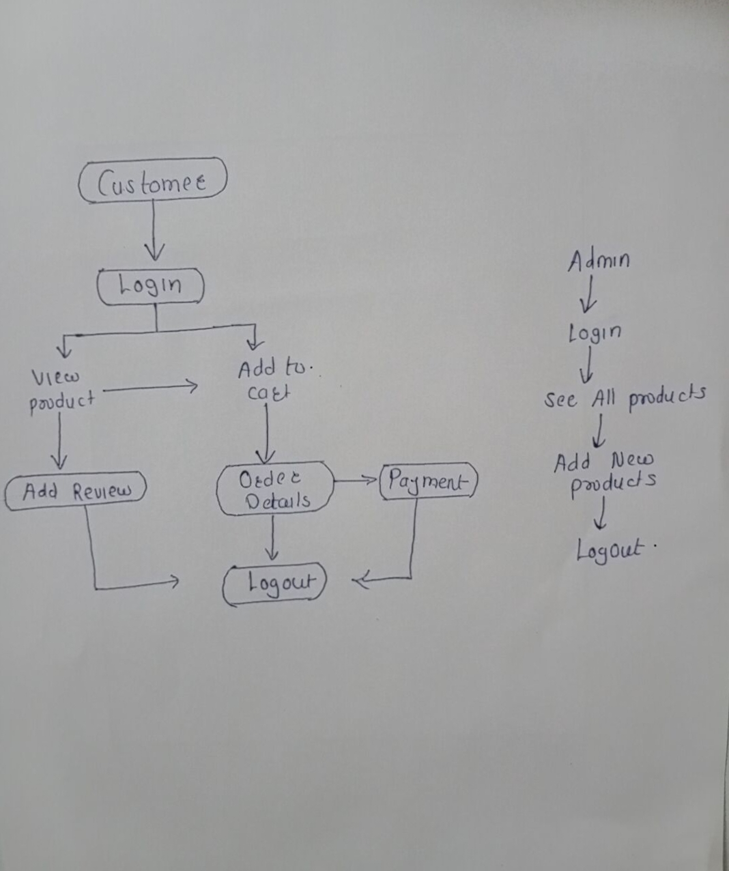

**Roles and Responsibilities:**

|  |  |  |
| --- | --- | --- |
| **Roles and Responsibilities** | | |
| 1 | Role | Leader |
| Member Name | **PRAJWAL PARASHKAR.** |
| PRN No | 220943120078 |
| Description | Database design, backend with springboot . |
| 2  + | Role | Backend design |
| Member Name | **PRAJWAL JAGTAP.** |
| PRN No | 220943120040 |
| Description | Database design, backend with springboot. |
| 3 | Role | Front end |
| Member Name | **AYYAJKHAN PATHAN** |
| PRN No | 220943120014 |
| Description | Database design, front end with react js. |
| 4 | Role | Front end |
| Member Name | **DHANRAJ KARVE** |
| PRN No | 220943120024 |
| Description | Database design, front end with react js. |

1. Future Scope of Project
2. Provide repair service for the Salon equipment.
3. Repair and re-introduce used salon products as refurbished category
4. Provide Attractive wallpapers, Furnitures and Renovations.
5. Also, we can Provide home services For Hair Spa and Waxing.

**Thank You!**